OAuth Step

Objective

OAuth is an authentication protocol that allows a user (resource owner) to grant a third-party application (consumer/client) access to their information on another site (resource).

OAuth (Open Authorization) is an open standard for token-based authentication and authorization on the Internet. OAuth, which is pronounced "oh-auth," allows an end user's account information to be used by third-party services, such as Facebook, without exposing the user's password.

UI

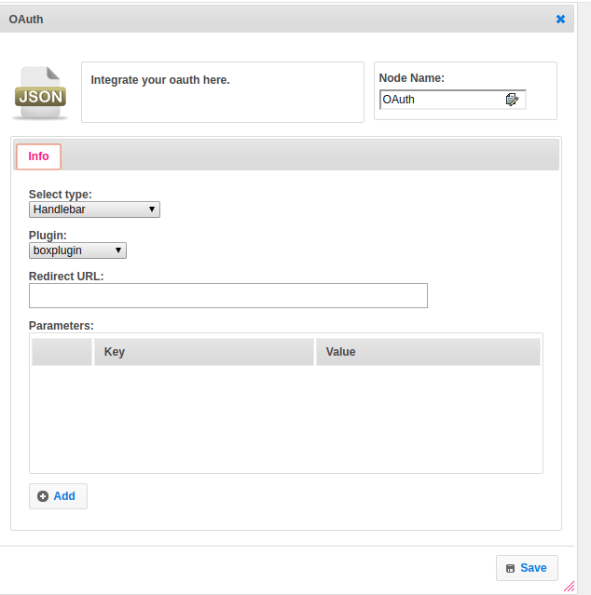

## Attributes

|  |  |
| --- | --- |
| **Attributes** | **Description** |
| **1. Select Template** | Select Template used to set the value type.  Value types are two types.  1.hb-HandleBars  2.ftl-Freemarker Template Language. |
| **2. Plugin** | Name of the plugin which contains the plugin configuration details. |
| **3. Redirect URL** | Redirect URL contains the URL, based on the URL execute the workflow. |
| **4. Parameters** | Parameter needs the data in the form of key, value pair. |

## ￼Executor Description

By using plugin name get the plugin information. Get the ServiceBuilder object by calling the get method and Identity Plugin object by calling a get-config method from the pluginHandler class.Set version of Oauth is 2 by default. If redirect_url is null through the exception. Build the authorization URL by concatenating additional params, concatenating scopes if not null and params and concatenate cookies. Finally, call the sendRedirect method by passing this authorization URL as a string. Here finally we get authorization_code.

## Resource

To get more information please refer the following link.

<https://developers.google.com/identity/protocols/OAuth2>